**1.** **Connect the power supply and connect the USB：**

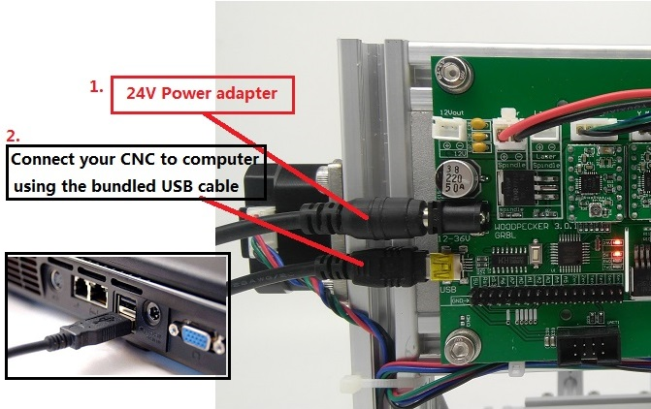

**2.** **Install the driver (** software --> Driver --> CH340SER.exe **) :**

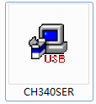

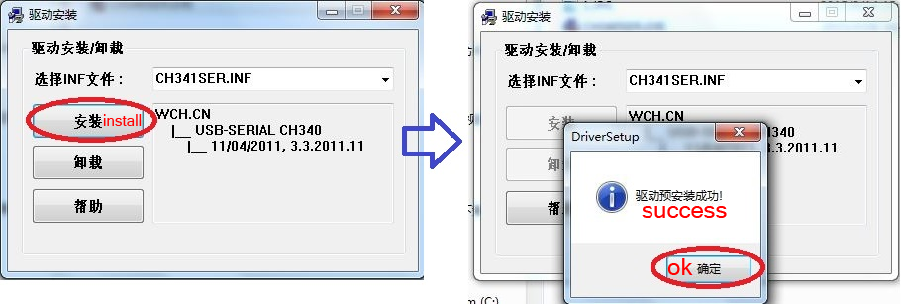

**3.** **To Determine your Machine's COM port:**

* Windows XP: Right click on "*My Computer*", select "*Properties*", select "*Device Manager*".
* Windows 7: Click "Start" -> Right click "*Computer*" -> Select "*Manage*" -> Select "*Device Manager*" from left pane
* In the tree, expand "*Ports (COM & LPT)*"
* Your machine will be the USB Serial Port (COMX), where the “X” represents the COM number, for example COM6.
* If there are multiple USB serial ports, right click each one and check the manufacturer, the machine will be "*CH340*".

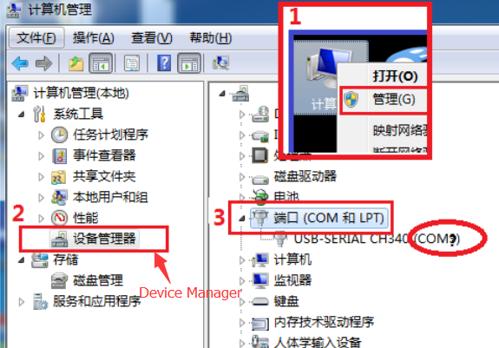

**4.** **Open grblControl software(**software -> Grblcontrol ->grblControl.exe**)**

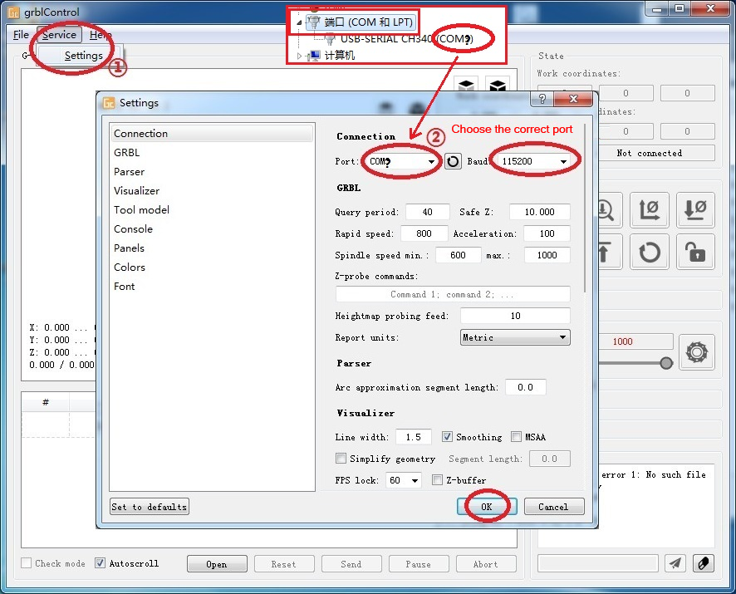

* Console window print ” [CTRL+X] < Grbl 0.9j ['$' for help]” If the connection is successful.
* Console window print ” Serial port error 1: No such file or directory “ indicate that the connection is failed.

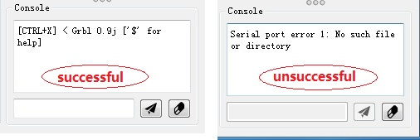

* Grblcontrol Use

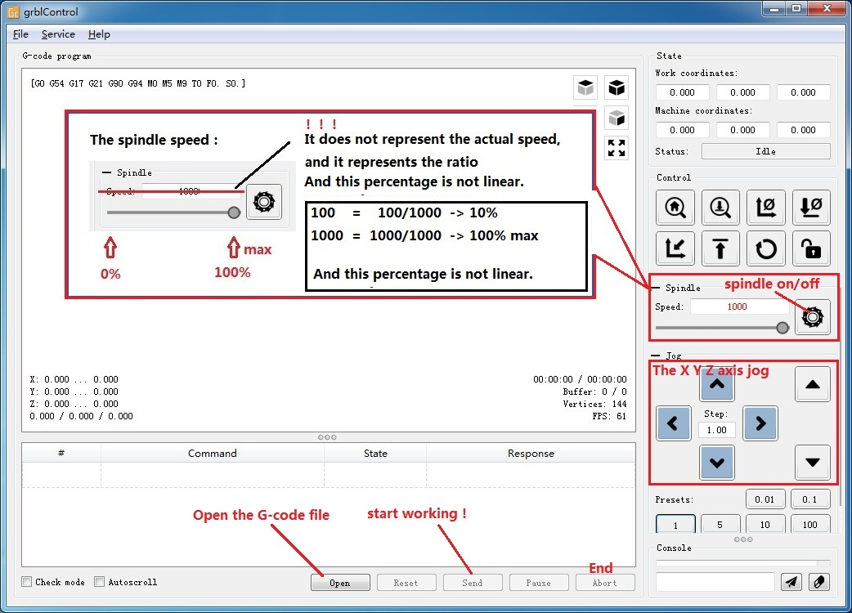

* Tool setting

